Docker Task -01

Task Title
Setup Docker Environment on Ubuntu EC2 and Run Containers with Jenkins Job Execution
Objective
To provision an Ubuntu-based virtual machine on AWS EC2, install Docker, manage multiple Docker images, run and expose containers, inspect Docker images, and deploy Jenkins in a container to execute a sample job, thereby demonstrating basic Docker and Jenkins CI usage.
Prerequisites
- AWS account with permission to create EC2 instances
- Ubuntu AMI selected for EC2 instance
- EC2 instance with public IP and internet access
- Security Group allowing inbound access on ports:
  - 22 (SSH)
  - 81 (nginx)
  - 8080 (Jenkins)
  - 50000 (Jenkins agents)
- Basic knowledge of Linux commands
- Basic understanding of Docker and Jenkins concepts

- Setup a virtual machine using Ubuntu image.
Steps performed:
- Launched one instances with ubuntu image
- Selected = t3.micro
- Security groups: Default
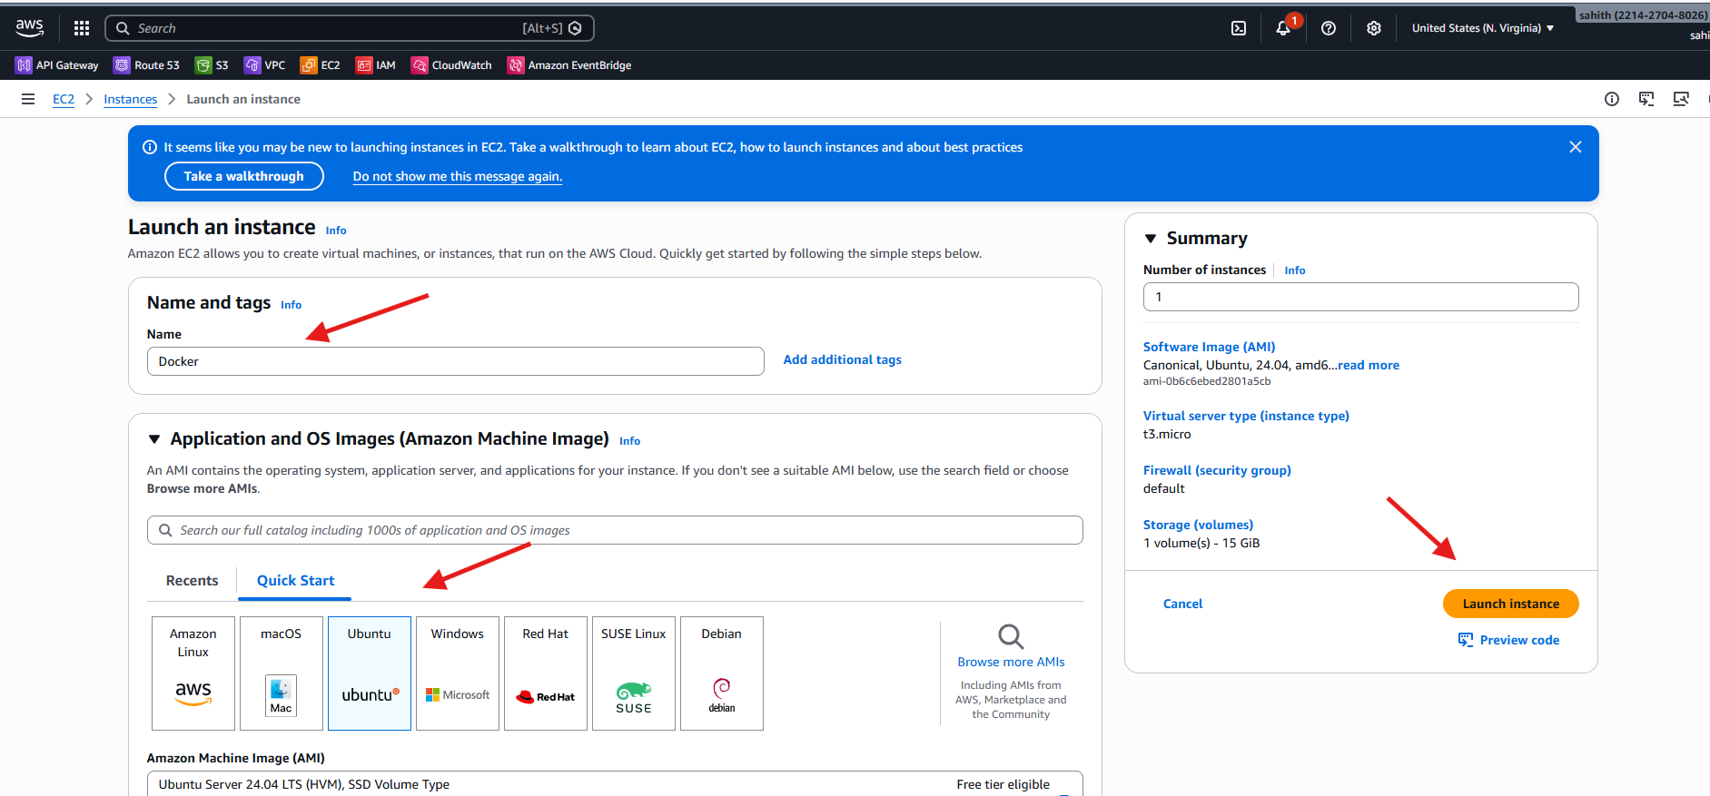
- Docker instance has launched sucessfully
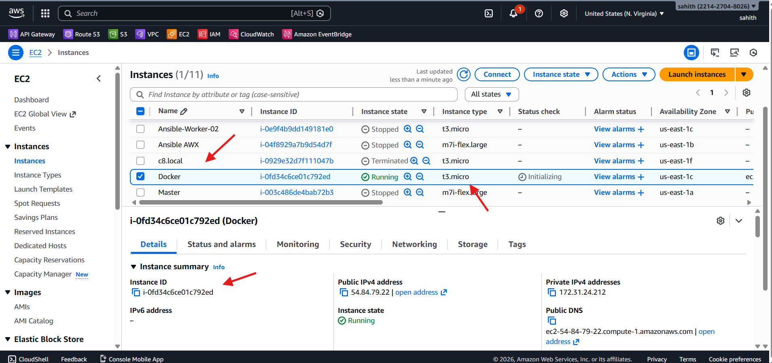
- Install docker on ec2.
Steps performed:
- First sshed into docker ec2
- Using command “apt install docker.io” installed docker
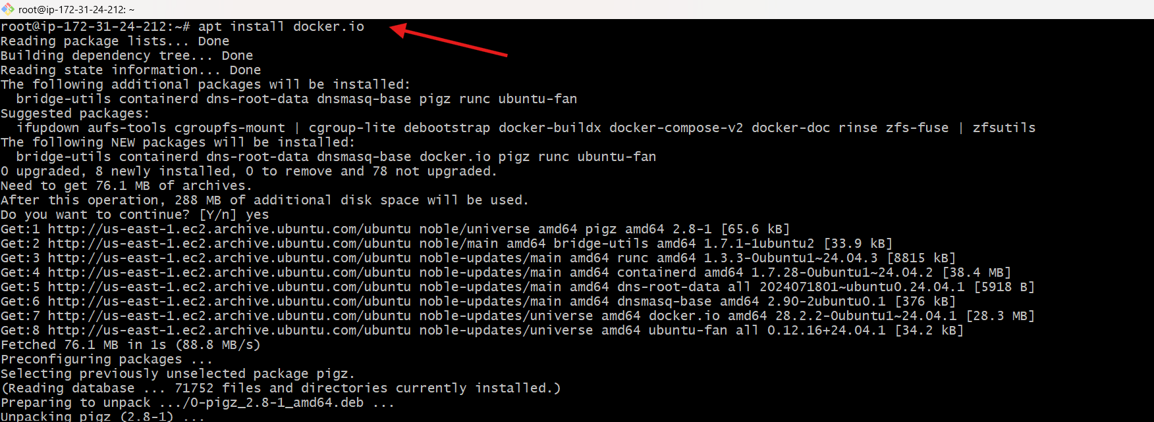

- Pull 5 docker images. (Nginx, Apache, tomcat, ubuntu, jenkins, sonarqube)

- Using command: “for i in nginx tomcat ubuntu jenkins/jenkins:lts sonarqube; do docker pull $i; done”
- Installed all 5 images nginx, Apache tomcat,ubuntu,jenkins,sonarqube
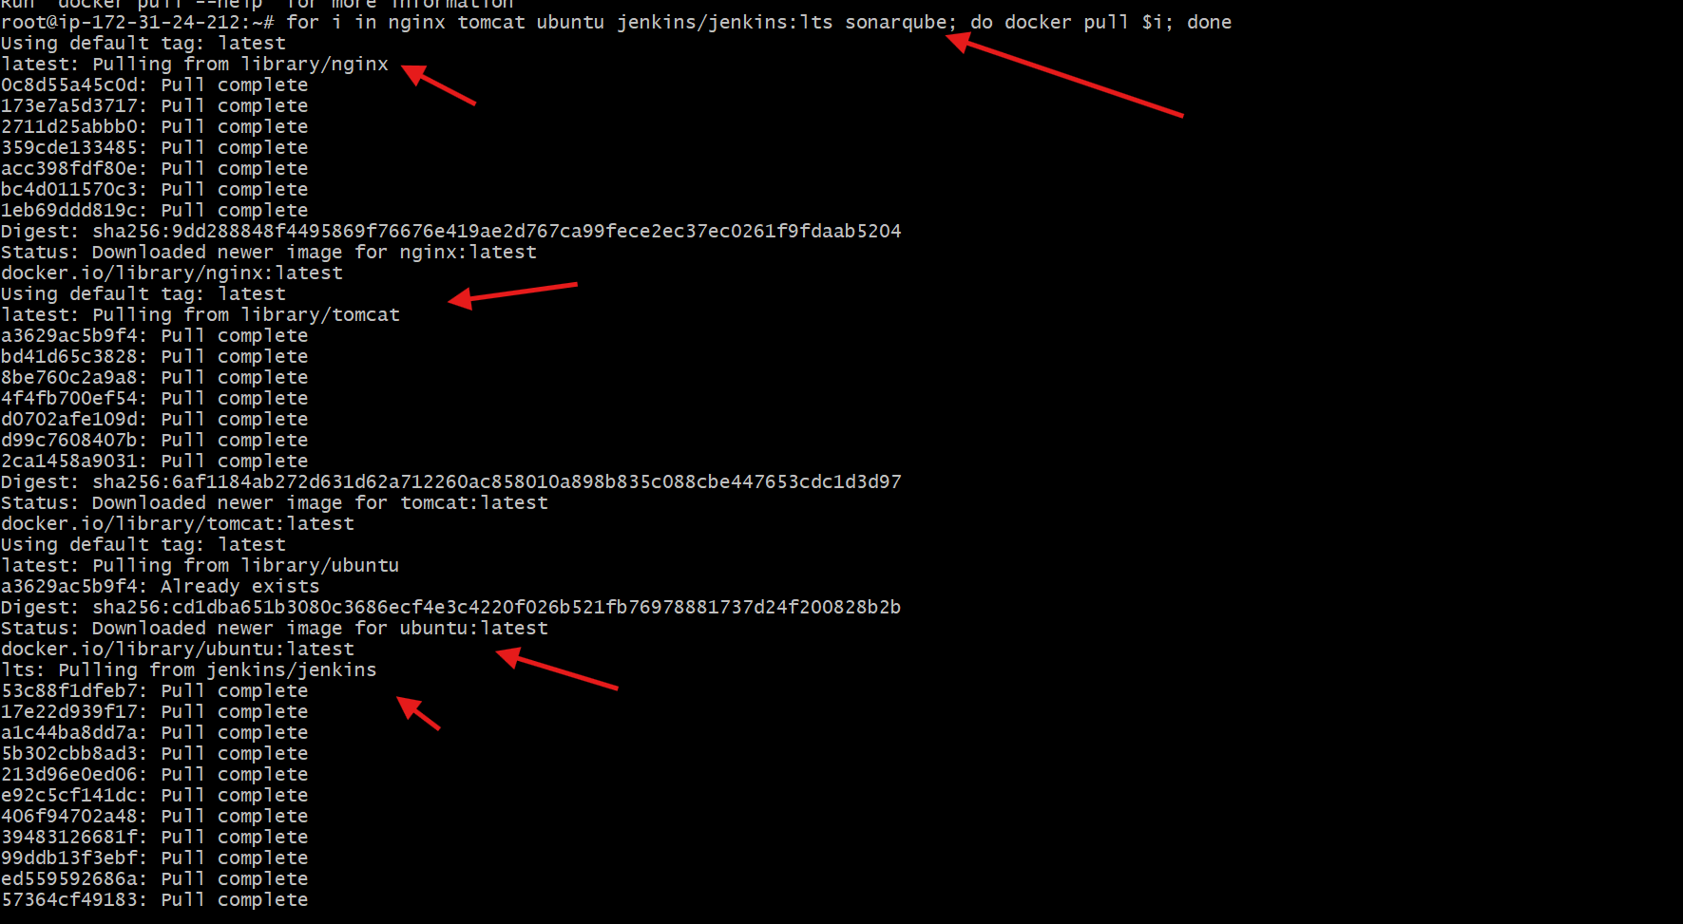
- As we can see in below images all 5 images has been downloaded successfully.
- Verified using command: “docker images”
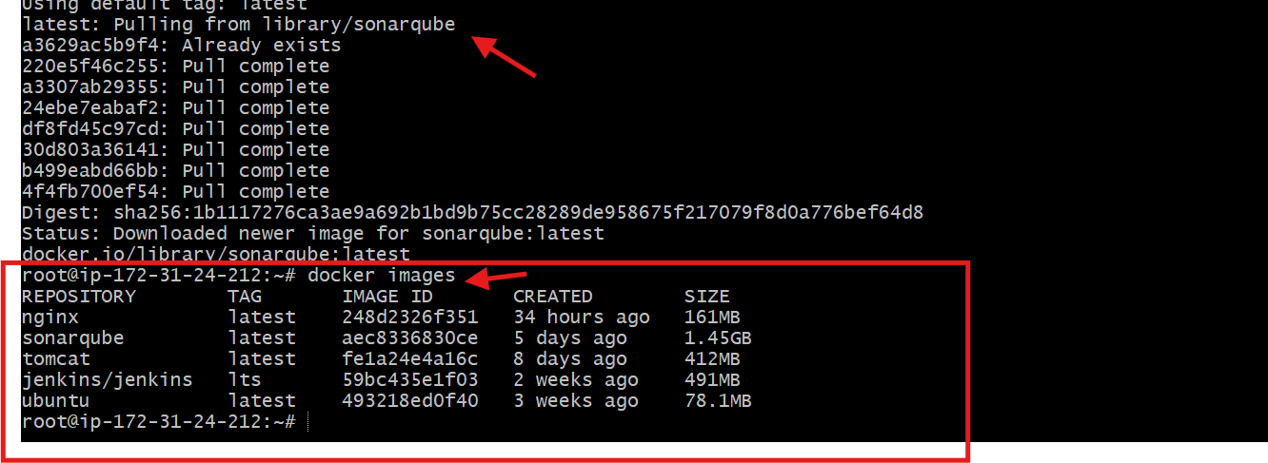
- Run nginx container and expose on port 81.
Steps performed:
- I have changed port number using command below
- Used command: “docker run -d --name nginx81 -p 81:80 nginx”
- Verified it using command: ” docker ps”
Validation steps:
- Browser public Ip of vm by adding :81 at end of Ip
- Nginx is successfully running on port number 81
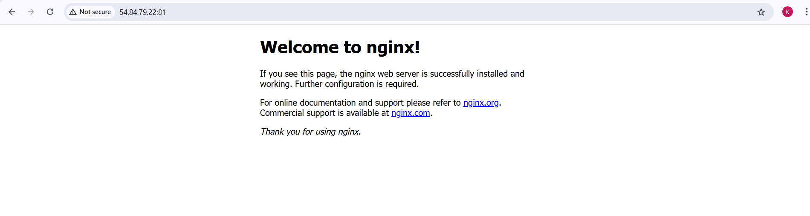
- Delete the Apache tomcat image from local.
Steps performed:
- First check if the apache tomcat image is installed or not
- Use command: “docker images”
- As we have tomcat image. Use below command to delate it.
- Use command to delete: “docker image rmi image ID
- Once deleted tomcat, again verified by using command: docker images.
- As we can see in below image tomcat has been deleted successfully.
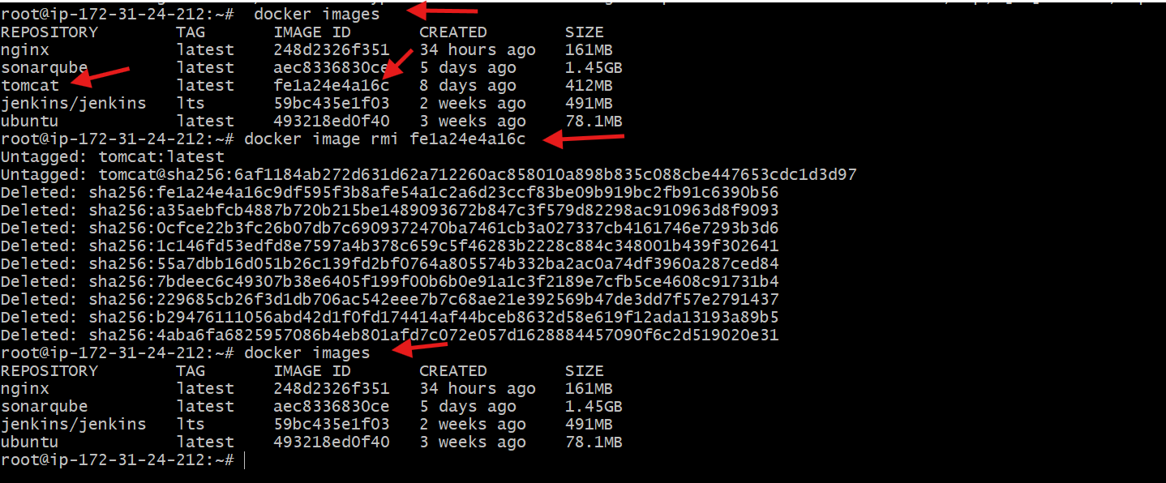

- Inspect the jenkins image, SonarQube image.
Steps performed:
Command used
docker image inspect jenkins/jenkins: lts
What the Jenkins Docker image contains:
- Linux base OS
- Jenkins runs on a Linux-based Docker image.
- Java (OpenJDK)
- Java is preinstalled to run Jenkins.
- Command reference:
JAVA_HOME=/opt/java/openjdk
- Jenkins application (LTS)
- Stable Jenkins Long-Term Support version.
- Command used to inspect version:
docker image inspect jenkins/jenkins:lts
- Default user
User: jenkins
- Jenkins runs as a non-root user.
- Exposed ports
8080/tcp → Jenkins Web UI
50000/tcp → Jenkins agent communication
- Environment variables
- Jenkins home, version, update center URLs, Java home.
- Seen using:
docker image inspect jenkins/jenkins:lts
- Entrypoint / Startup
/usr/bin/tini
/usr/local/bin/jenkins.sh
- Starts Jenkins safely inside the container.
- Volume
/var/jenkins_home
- Stores Jenkins jobs, plugins, and configuration.
- Architecture & OS
Architecture: amd64
OS: linux
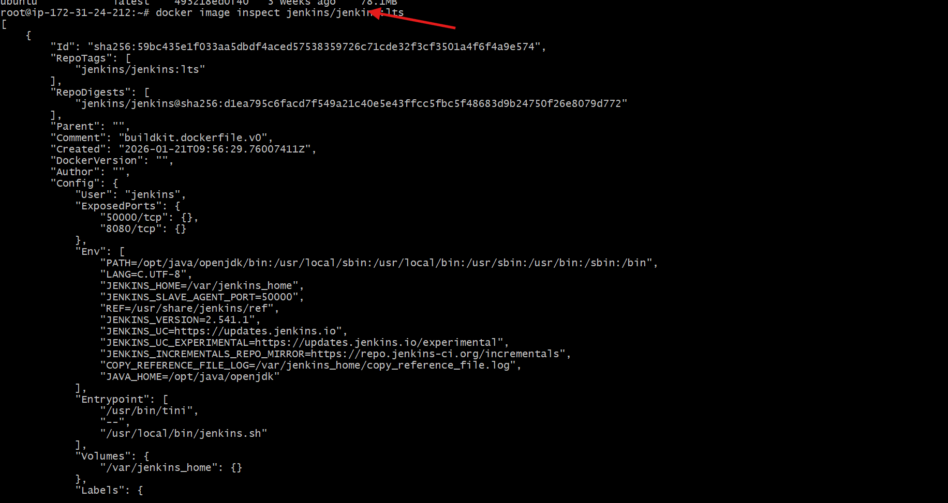
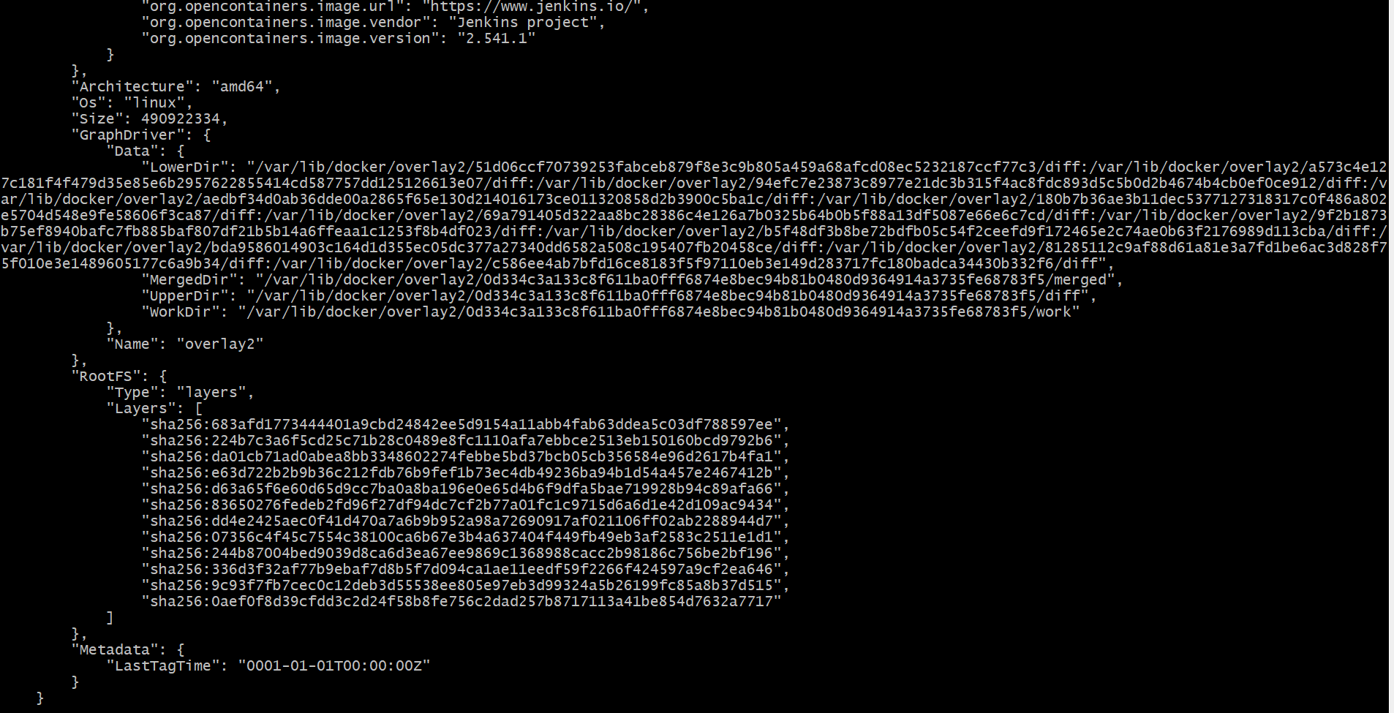

The SonarQube Docker image contains:
- Linux base OS (Ubuntu)
  - The image is built on Ubuntu.
- Java (OpenJDK)
  - Required to run SonarQube.
  - Java path is already configured inside the image.
- SonarQube application
  - Core SonarQube server binaries.
  - Used for static code analysis and code quality checks.
- Elasticsearch
  - Embedded search engine used by SonarQube for indexing and searching issues.
- Default port configuration
  - Exposes port 9000 for web access.
- Startup script
  - Entrypoint script that automatically starts SonarQube when the container runs.
- Predefined directories
  - /opt/sonarqube/data → data storage
  - /opt/sonarqube/logs → logs
  - /opt/sonarqube/extensions → plugins
- Environment variables
  - Java home, SonarQube home, version, and runtime settings.
- Used command: docker image inspect sonarqube
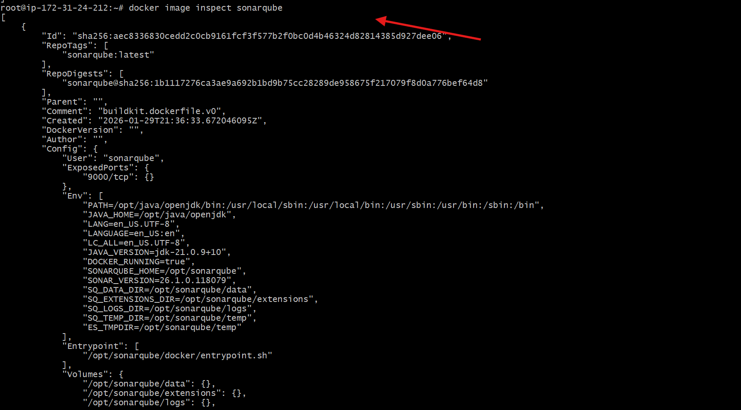
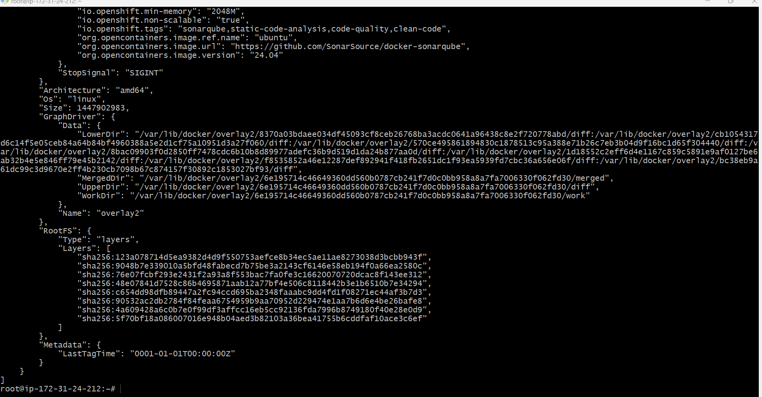

- Run Jenkins container and run one sample job.
Steps Performed
- Ran the Jenkins Docker container with required port mappings:
- docker run -d --name jenkins -p 8080:8080 -p 50000:50000 jenkins/jenkins:lts
- Verified the Jenkins container status:
- docker ps
- Retrieved the Jenkins initial admin password:
- docker exec jenkins cat /var/jenkins_home/secrets/initialAdminPassword
- Accessed Jenkins web interface using the public IP and port 8080:
- http://<public-ip>:8080
- Unlocked Jenkins by entering the initial admin password.
- Installed suggested Jenkins plugins during first-time setup.
- Created a new Jenkins job by clicking New Item.
- Entered the job name as Docker sample-task.
- Selected Freestyle project and clicked OK.
- Opened job Configure page.
- Navigated to Build Steps section.
- Added Execute shell build step.
- Entered sample e-commerce shell script in the build step.
- Saved the job configuration.
- Clicked Build Now to run the job.
- Opened Console Output to verify execution.
- Confirmed successful build execution with e-commerce workflow messages

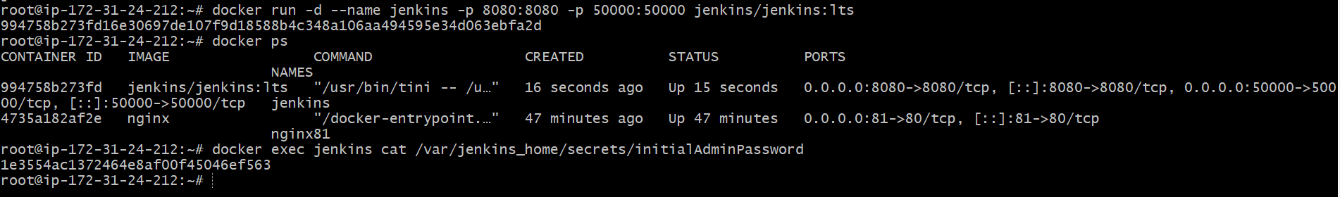
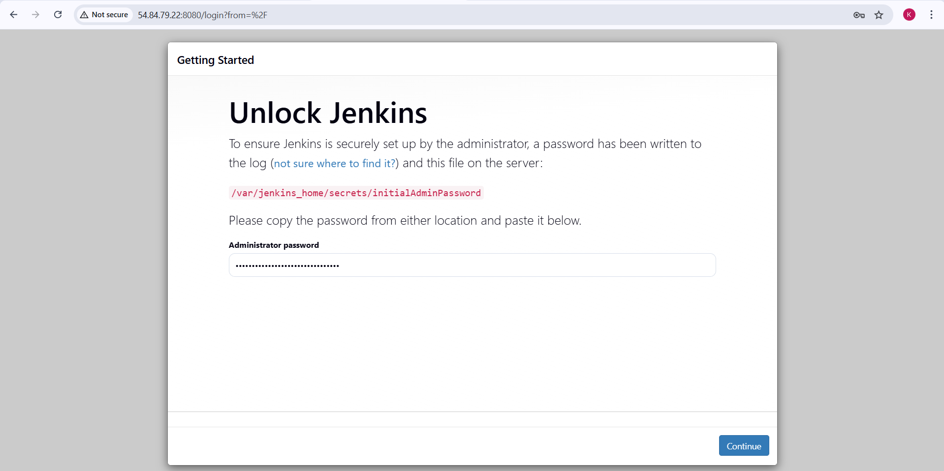
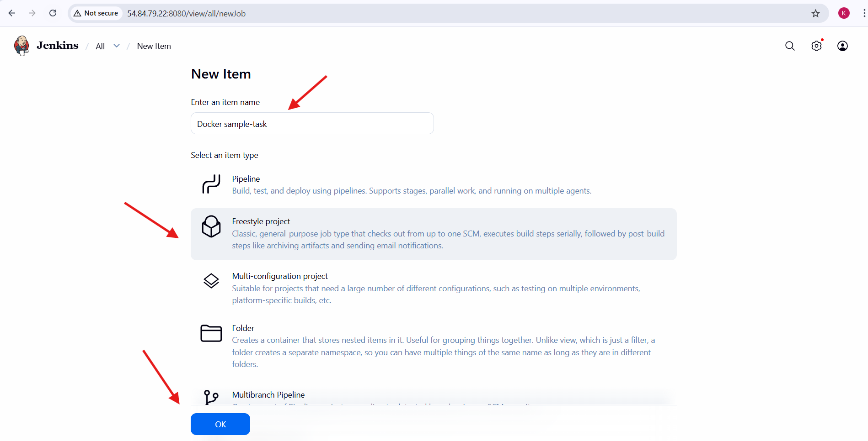
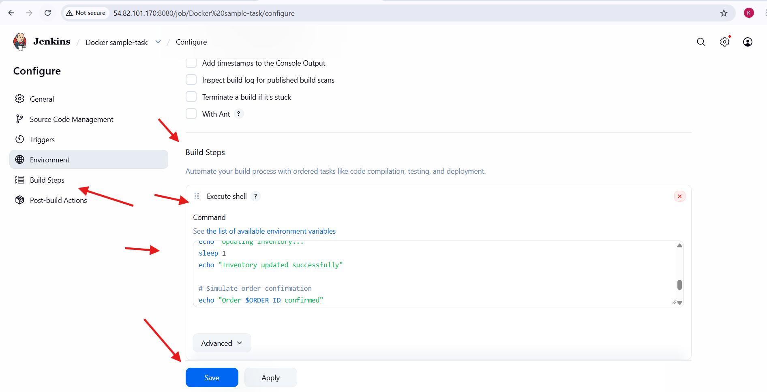
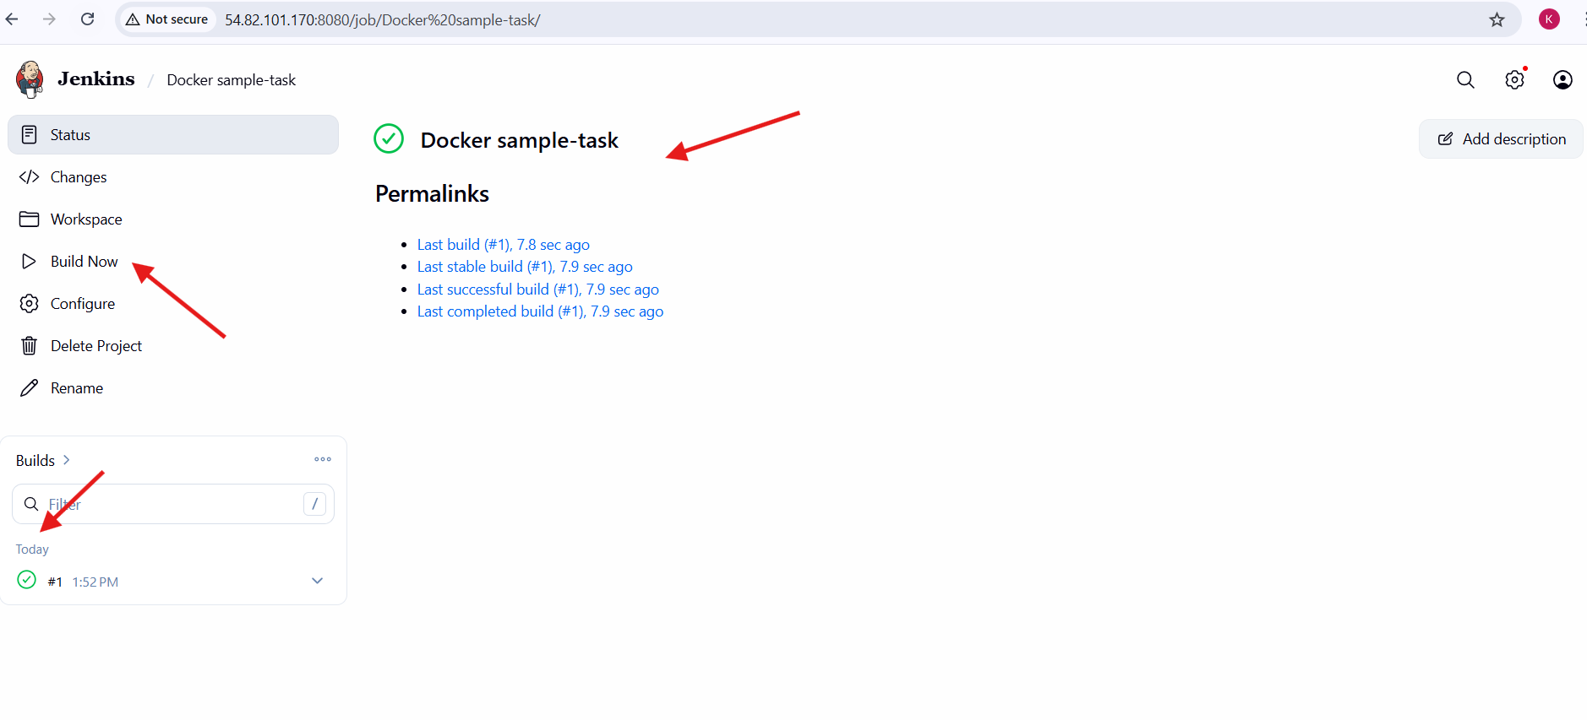
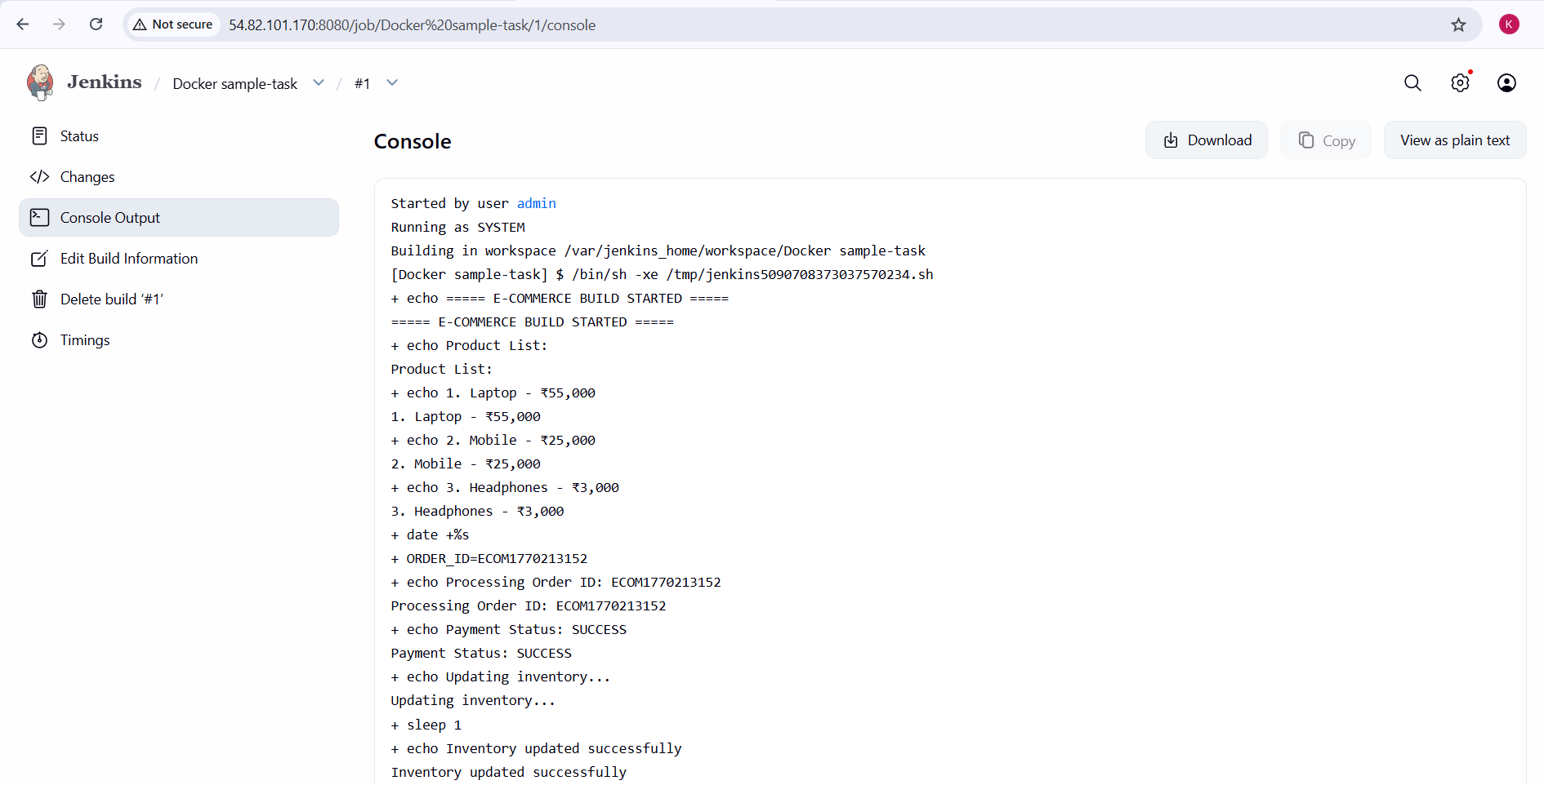
Conclusion
The Ubuntu EC2 virtual machine was successfully provisioned and Docker was installed. Multiple Docker images including nginx, Ubuntu, Jenkins, SonarQube, and Apache Tomcat were pulled and managed. An nginx container was deployed and exposed on port 81. The Apache Tomcat image was removed from the local system. Jenkins and SonarQube images were inspected to review their configurations. Jenkins was successfully run inside a Docker container, accessed via the web interface, and a sample job was created and executed successfully, confirming proper Docker and Jenkins setup.

